Intent
Mathematics is a creative and highly inter-connected discipline that has been developed over centuries, providing the solution to some of history’s most intriguing problems. It is essential to everyday life, critical to science, technology and engineering, and necessary for financial literacy and most forms of employment.
A high-quality mathematics education therefore provides a foundation for understanding the world, the ability to reason mathematically, an appreciation of the beauty and power of mathematics, and a sense of enjoyment and curiosity about the subject.
National Curriculum 2013
Intent
The 2014 National Curriculum for Maths aims to ensure that all pupils:
- become fluent in the fundamentals of mathematics, including through varied and frequent practice with increasingly complex problems over time, so that pupils develop conceptual understanding and the ability to recall and apply knowledge rapidly and accurately
- reason mathematically by following a line of enquiry, conjecturing relationships and generalisations, and developing an argument, justification or proof using mathematical language
- can solve problems by applying their mathematics to a variety of routine and non-routine problems with increasing sophistication, including breaking down problems into a series of simpler steps and persevering in seeking solutions.

At Springwood Heath, these skills are embedded within Maths lessons and developed consistently over time. We are committed to ensuring that children are able to recognise the importance of Maths in the wider world and that they are also able to use their mathematical skills and knowledge confidently in their lives in a range of different contexts. We want all children to enjoy Mathematics and to experience success in the subject, with the ability to reason mathematically. We are committed to developing children’s curiosity about the subject, as well as an appreciation of the beauty and power of Mathematics.

Implementation (Overviews)
Early Years
EYFS follow White Rose Maths planning which is in line with the new statutory framework for EYFS.  In EYFS mathematical activities take place as an integral part of the child’s daily experience. These mathematical experiences are part of their topic work and relate directly to the child's understanding of everyday life; role play is vital in this aspect. Children have the opportunity to consolidate their learning during independent activities. The aim of these activities is to develop the child's number skills and the skills of ordering, sequencing, matching, grouping and number recognition and to develop mathematical ideas and methods to solve practical problems.  It is through these activities where children are working co-operatively in groups and discussing their learning with other children and their teachers that they are encouraged to develop and use mathematical language. Most of these experiential activities will be planned and structured within half-termly and weekly planning to ensure differentiation and progression. | 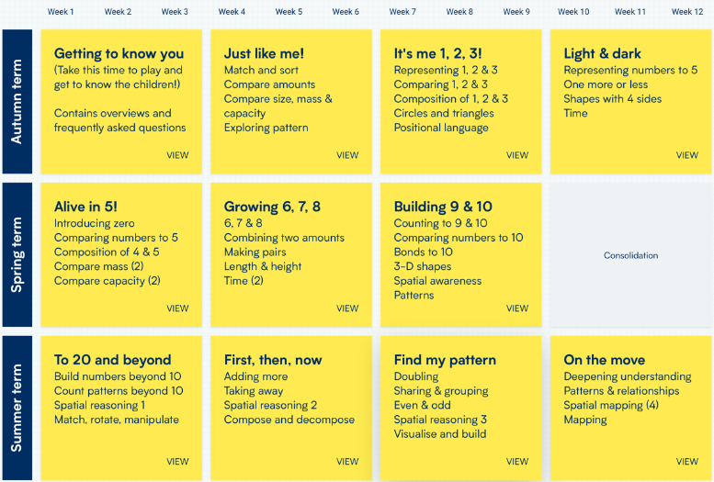
KS1
In KS1 teachers use the White Rose Scheme of Learning resources to support the careful planning of each small step for each unit.  This is underpinned by the concrete, pictorial, abstract (CPA) approach. Classrooms have a range of mathematical resources made available for children in each key stage.  Resources include, but are not limited to, Numicon, Base 10, place value counters, bead strings, number lines, digit cards and hundred squares. | Year 1  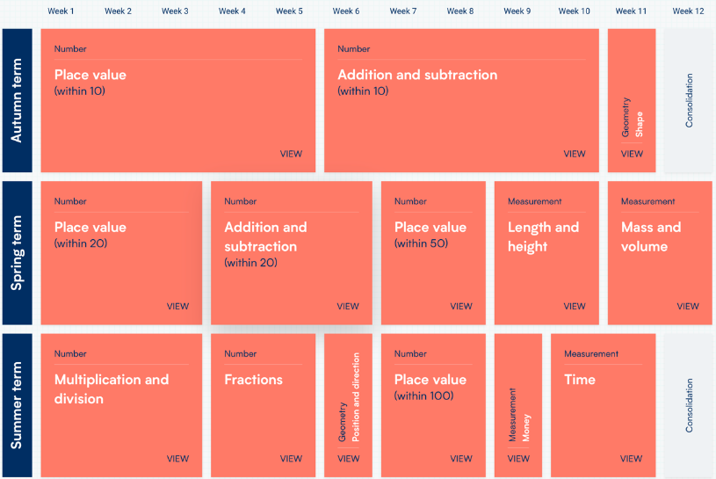  Year 2  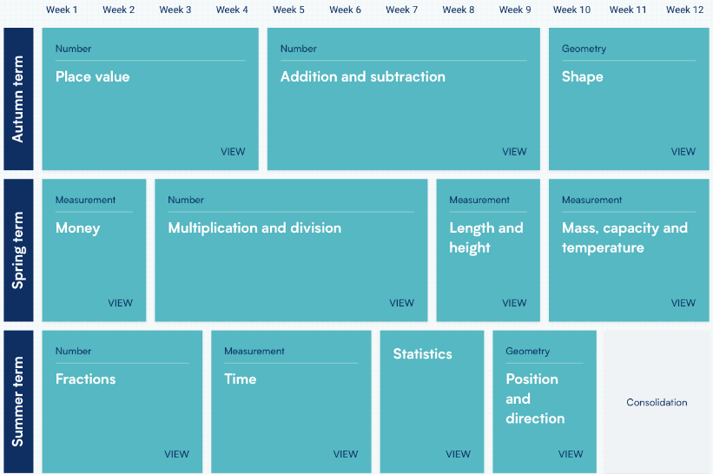
KS2
In KS2 teachers continue to follow the White Rose Scheme of learning resources to plan and deliver maths teaching and learning.  There is a continuation of the use of the concrete, pictorial, abstract (CPA) approach.  Regular use of ‘TTRockstars’, within school and home enables children to practise multiplication and division knowledge.  Mathletics and Maths.co.uk are regularly used on class and for homework to support learning, basic skills and times tables knowledge.  Throughout each lesson formative assessment takes place and feedback is given to the children through marking and where appropriate targets set to ensure they are meeting the specific learning objective. Teacher’s then use this assessment to influence their planning and ensure they are providing a mathematics curriculum that will allow all children to progress. | Year 3  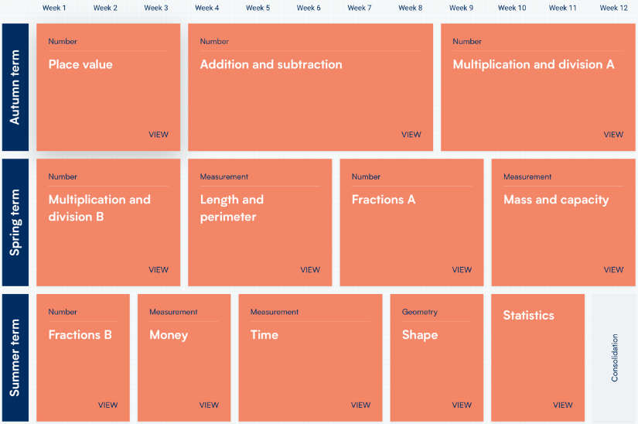  Year 4  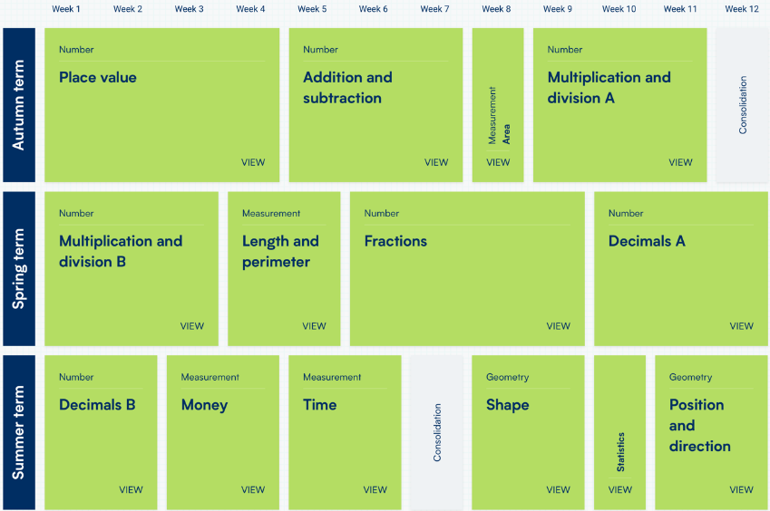  Year 5  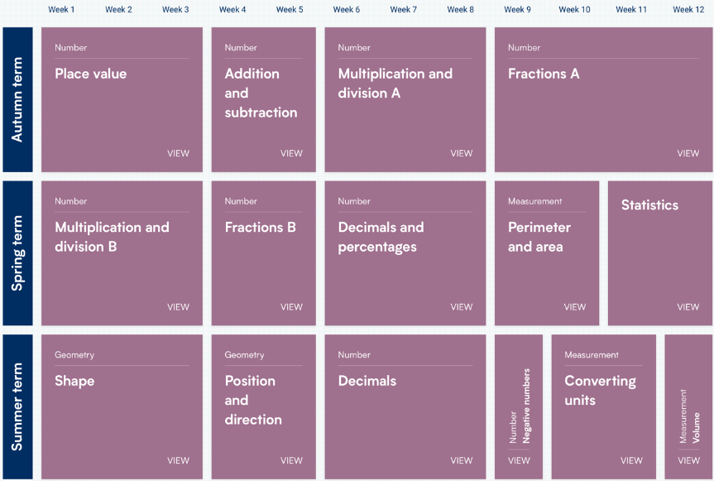  Year 6  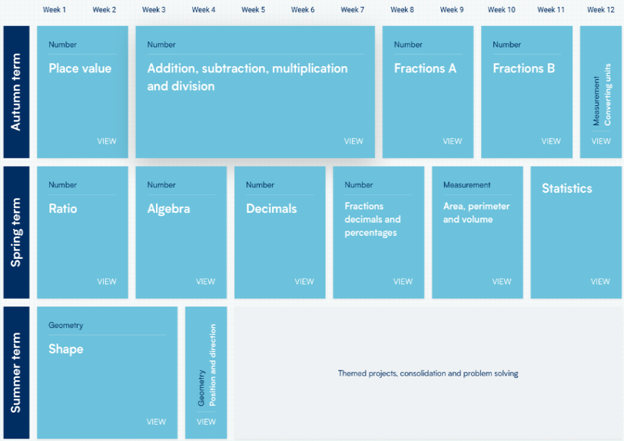
Vocabulary
Teachers use White Rose Scheme of Learning to help plan in possible sentence stems for each step taught. Vocabulary is progressive and we follow a separate language progression document which informs teachers of what to expect and how to build on children's previous knowledge.  Appropriate language for each step is briefly shared at the beginning of each lesson but is explored more in detail during the part of the lesson where language is used to enhance a deeper understanding.  Teachers also refer to White Rose's calculation policy glossary to ensure that language is consistent across school. This supports children when making generalisations and explaining their thinking. | 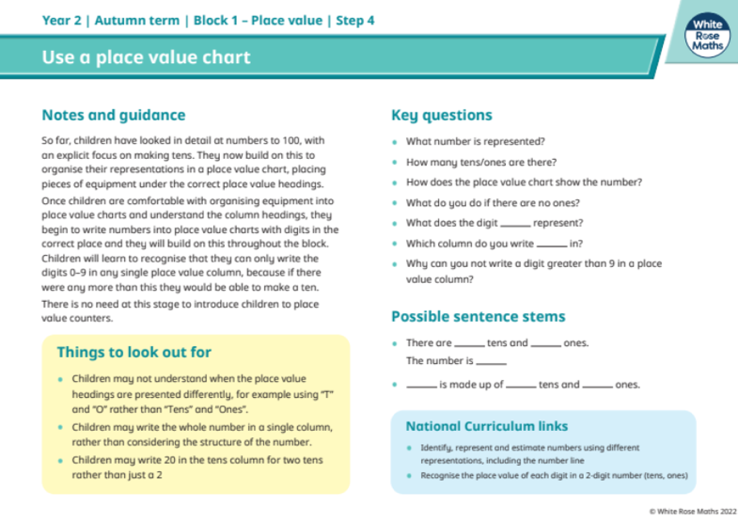  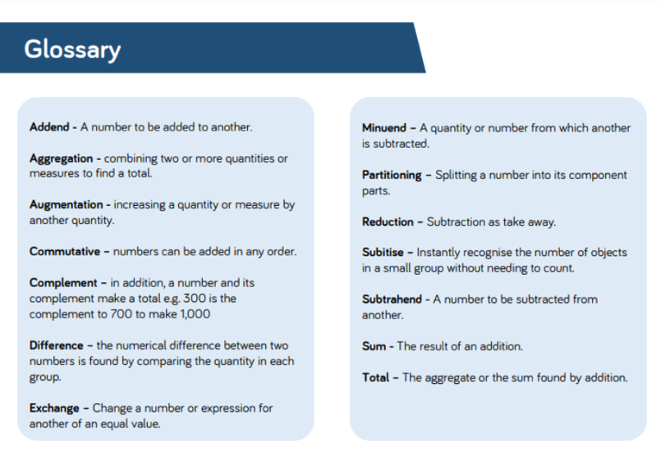
Impact
How do we know what children have learnt
- Impact is evident in our most recent KS1 and KS2 progress measures and also in Teacher Assessment data.
- Children have quick recall of facts and procedures as well as the flexibility and fluidity to move between different contexts and representations of mathematics.
- Children have the ability to recognise relationships and make connections in mathematics.
- Children understand that maths is an important skill for life.
- Staff are confident in numeracy and maths which results in increased pupil confidence.
- Book scrutinies and lesson visits demonstrate progression and confidence in maths across the school.
- Pupil voice shows that children enjoy maths lesson and enjoy a challenge, they feel that they are fully supported and know what to do when they need extra help.
- TT Rock Stars data demonstrates that the time taken for children to rapidly recall times table facts has improved year on year.
- Mathletics Data shows children’s engagement both in school and at home.

