Engagement Model

**‘If a child can’t learn the way we teach, maybe we should teach the way they learn’**

At Springwood Heath, for those children who are working below the standard of the national curriculum and are not engaged in subject-specific study, we follow the **engagement model**. This is a pupil-centred approach which allows teachers to make valuable assessments of children to identify areas they need further support in, as well as identifying areas of strength. The engagement model values all sources of knowledge and information provided by those working with our children including school staff, multi-agency professionals and parents/carers. It recognises there is a complex interaction between pupils’ physical, sensory, communication and learning disabilities that affects how they progress.

The engagement model looks specifically at how students engage with their learning in five different areas:

* **Initiation**: building independence
* **Persistence**: determination to succeed
* **Exploration**: showing curiosity
* **Anticipation**: prediction of events
* **Realisation**: light bulb moments

In our Swans class children work on a bespoke curriculum, designed to meet their diverse needs. The engagement model focuses on children’s abilities rather than disabilities. Regular observations conducted by staff who know the children well help establish progress across the five areas taking into consideration children’s linear and lateral progress, the consolidation and maintenance of their knowledge, skills and concepts and their uniqueness as a learner.

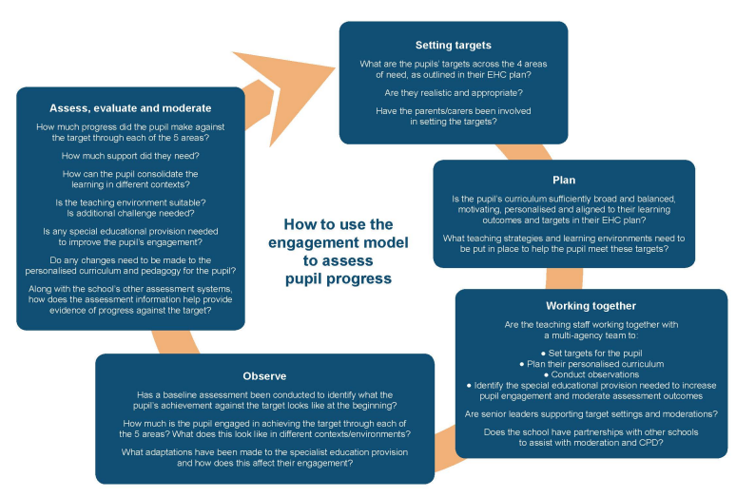

Pupils’ progress and development is regularly assessed throughout the school year which enables a continuous cycle of ‘assess, plan, do and review’ to take place. We look at how well pupils are engaged in developing new skills, knowledge and concepts, how effective our provision is in empowering pupils to progress against the agreed outcomes in their EHC plans and how effectively pupils are progressing across the 4 areas of need of the SEND code of practice (communication and interaction, cognition and learning, social, emotional and mental health difficulties and sensory and/or physical needs). We meet with parents/carers through regular ‘Planning for Progress’ meetings to ensure home and school are working together.

Using engagement as the focus of statutory assessment for pupils who are not engaged in subject-specific study helps to ensure that they are developing the right skills and concepts in their physical, social, emotional and cognitive development. This can help them progress on to subject-specific study, when they feel confident enough to do so.